Introduction to Software
Software Engineering

- What is software?
- Software is a set of instructions (computer programs) that tell a computer what to do. It also includes data structures that help the program work with information and documents that explain how to use the software.

- What are the objectives of software engineering?
-
- Understand what users want and create better plans.
- Improve design languages and reusable code.
- Create better interfaces and confirm specifications.
- Improve the quality of software.
- Make software engineers more productive and satisfied with their work.

- Importance of Software Engineering?
-
- Reliable and trustworthy software is essential for modern life.
- Planning and engineering methods reduce long-term costs.
- Updating software is a major expense, so good design is crucial.

- What is the difference between software engineering and system engineering?***
- 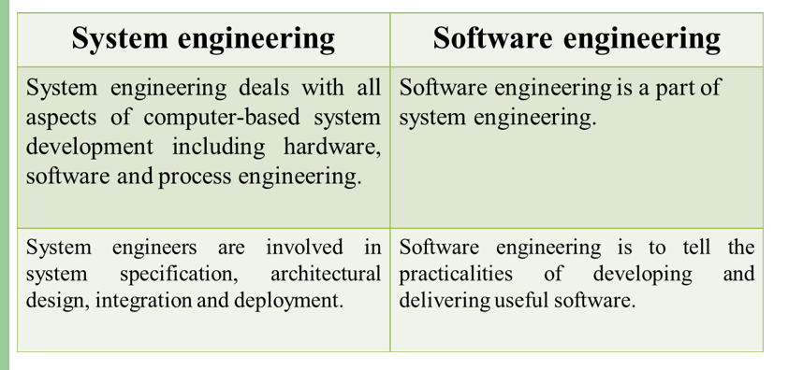

- What are the characteristics of software?
-
- Software is developed, not manufactured like physical products.
- Software doesn’t wear out over time like hardware.
- Most software is custom-built, not assembled from pre-made parts.
- High-quality software comes from good design.

- Why doesn’t software wear out?/ “Software doesn’t wear out” describe it.***
- Software doesn’t wear out because it is not affected by environmental factors like dust or temperature. However, it can develop problems if changes are made to it over time.

- What are the attributes of good software?
-
Maintainability: It should be easy to update and change.

Dependability: It should be reliable and trustworthy.

Efficiency: It should use system resources wisely.

Acceptability: Users should find it easy to use and understand.

- What are the different types of software applications?***
-
- System software: Like compilers, editors, and file management tools.

- Application software: Programs for specific tasks.

- Real-time software: Controls real-world events as they happen.

- Personal computer software: Like word processors, spreadsheets, and games.

- Engineering/scientific software: Used for complex calculations.

- Web-based software: Software that runs on the internet.

- Embedded software: Software inside devices like microwaves or cars.

- Artificial intelligence software: Solves complex problems using non-numerical methods.

